**Currency Converter**

Submitted in partial fulfillment of the requirements of the degree

**BACHELOR OF ENGINEERING IN COMPUTER ENGINEERING**

By

**Khan Arshad Abdulla 20CO24**

Supervisor

**Prof. Tabrez Khan**

**_______________________________________**

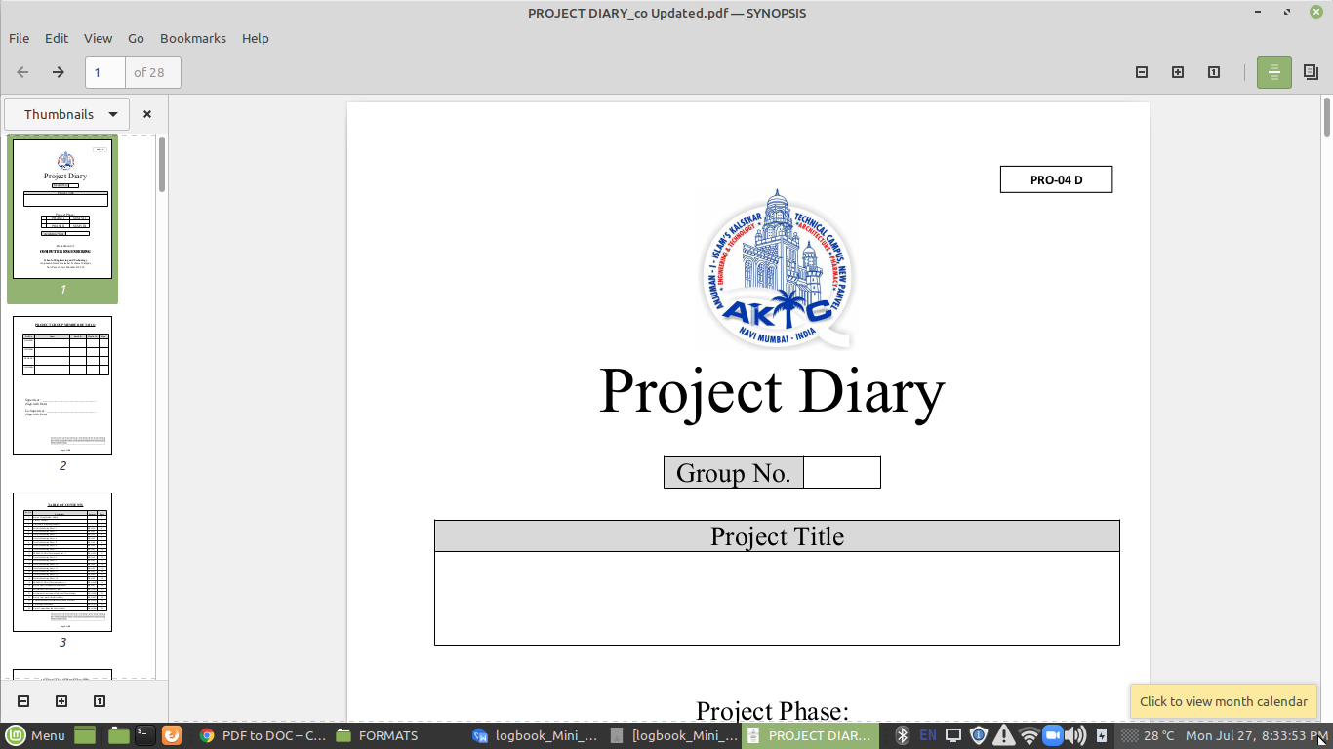

Department of Computer Engineering

**Anjuman-I-Islam's Kalsekar Technical Campus**

**School of Engineering,**

Plot No. 2 & 3, Sector - 16, Near Thana Naka,

Khandagao, New Panvel, Navi Mumbai, Maharashtra 410206

**(AY 2021-22)**

**CERTIFICATE**

This is to certify that the Mini Project entitled “**Currency Converter**” is a bonafide work of Name of **Arshad Khan(20CO24)** submitted to the University of Mumbai in partial fulfillment of the requirement for the award of the degree of **“Bachelor of Engineering”** in **“Computer Engineering”** .

(**Prof. Tabrez Khan**)

Supervisor

(**Prof. Tabrez Khan**) (**Prof. Abdul Razzak Honotagi**)

Head of Department Director

**Mini Project Approval**

This Mini Project entitled “Currency Converter” by Name of **Arshad Khan(20CO24)** is approved for the degree of Bachelor of Engineering in Computer Engineering.

Examiners

1.............................................

(Internal Examiner Name & Sign)

2................................................

(External Examiner name & Sign)

Date:

Place:

**Contents**

|  |  |  |  |
| --- | --- | --- | --- |
|  |  | Abstract |  |
|  |  | Acknowledgments |  |
|  |  |  |  |
|  |  |  |  |
|  |  |  |  |
|  |  |  |  |
|  |  |  |  |
|  |  |  |  |
|  |  |  |  |
| 1 |  | Introduction |  |
|  | 1.1 | Introduction |  |
|  | 1.2 | Motivation |  |
|  | 1.3 | Problem Statement & Objectives |  |
|  |  |  |  |
|  |  |  |  |
| 2 |  | Literature Survey |  |
|  | 2.1 | Survey of Existing System |  |
|  | 2.2 | Limitation Existing system or research gap |  |
|  | 2.3 | Mini Project Contribution |  |
|  |  |  |  |
| 3 |  | Proposed System (eg New Approach of Data Summarization ) |  |
|  |  |  |  |
|  | 3.1 | Architecture/ Framework |  |
|  | 3.2 | Algorithm and Process Design |  |
|  | 3.3 | Details of Hardware & Software |  |
|  | 3.4 | Experiment and Results |  |
|  | 3.5 | Conclusions |  |
|  |  |  |  |
|  | 3.6 | References |  |

**Abstract**

There are around 200+ different currencies used in different countries around the world. Conversion from one currency to another is a very important endeavour especially when it comes to marketing and travel. A currency conversion system is implemented to reduce human power to automatically recognize the amount monetary value of the currency and convert it into the other currencies without human supervision. The software interface that we are proposing here could be used for various currencies.

Many times, the stress and brain work required for manual currency conversion are much. Sometimes currency notes are blurry or damaged; many of them have complex designs to enhance security. This makes the task of currency recognition very difficult. So, it becomes very important to select the right features and proper algorithm for this purpose. The basic requirements for an algorithm to be considered as practically implementable are simplicity, less complexity, high speed, and efficiency. Our main aim is to design an easy but efficient algorithm that would be useful for a maximum number of currencies, because all currencies have different security features, making it a tough job to design one algorithm that could be used for recognition of all available currencies. Writing different programs for all is also a tedious job. This project will be designed using Python programming language for the front-end and MySQL for the back-end.

**Acknowledgments**

I would like to take the opportunity to express my sincere thanks to my guide **Prof.Tabrez Khan**, Assistant Professor, Department of Computer Engineering, AIKTC, School of Engineering, Panvel for his invaluable support and guidance throughout my project research work. Without his kind guidance & support this was not possible.

I am grateful to him/her for his timely feedback which helped me track and schedule the process effectively. His/her time, ideas and encouragement that he gave is help me to complete my project efficiently. We would like to express deepest appreciation towards **DR. ABDUL RAZAK HONNUTAGI**, Director, AIKTC, Navi Mumbai, Prof. TABREZ KHAN, Head of Department of Computer Engineering and **Prof. NUSRAT JAHAN**, Project Co-ordinator whose invaluable guidance supported us in completing this project. At last we must express our sincere heartfelt gratitude to all the staff members of Computer Engineering Department who helped me directly or indirectly during this course of work.

**Introduction**

**Motivation**

The staffs who work at places like money exchange offices have to distinguish between different types of currencies and convert them to other currencies and that is not an easy job. They have to remember the symbol of each currency. This may result in wrong recognition, so they need an efficient and full proof system to aid in their work. Our system aims to help people who need to recognize different currencies and be able to convert them to another currency using a known exchange rate. With the development of modern banking services, automatic methods for paper currency recognition become important in many applications such as vending machines. It is very difficult to count different denomination notes in a bunch.

This project proposes an image processing technique for paper currency recognition and conversion. The extracted region of interest (ROI) can be used with Pattern Recognition and Neural Networks matching technique. Image Processing involves changing the nature of an image to improve its pictorial information for human interpretation. There are various techniques for currency recognition that involve texture, pattern, or colour-based. We use digital image processing techniques to find region of interest, after that Neural Network and Pattern Recognition Technique is used for matching the pattern. Several methods for banknote classification have been proposed. Template matching is often used as a simple method to classify banknotes.

However, new templates or matching rules are required for new bill types. An effective way to overcome the problem is to extract features from bill images representing unique characteristics of bill data. After studying different currencies and considering the availability, we have chosen 6 currencies to work on for this project. The chosen currencies are Indian Rupees (INR), Canadian Dollar (CAD), Euro (EUR), Danish Krone (DKK), Chinese Yun (CYN) and US Dollar (USD).

**Problem Statement & Objectives**

Currently, human is needed to recognize the amount of the currency and to convert it manually. This is stressful, especially to people who aren’t so smart in calculations. So, this project is developed to replace human power to recognize the amount of the currency.

Currency Recognition and converter system are implemented to reduce human power to automatically recognize the amount of currency and convert it into other currency without human supervision.

**Mini Project Contribution**

The project contributes in providing a new experience to user on converting various currency values. A group of Three students from S.E Computer Branch, Arshad Khan, Taabish Gazi and Tayyab Shaikh worked on this project together. **Prof. Tabrez Khan Sir** guided us for the project.

**Proposed System**

**Introduction**

Currency Converter first display a web application where user can choose to display the converter or the exchange rate of one currency with all other currencies in the form dropdown .In the converter the user gets a choice to choose two currency names from the list of currency names displayed.

Then user should give input by putting currency value and select the currency in which he wants to convert. After clicking the convert button the currency will be converted and new converted currency will be displayed. Also user can clear all the converted currency amount by clicking clear button.

**Architecture/ Framework**

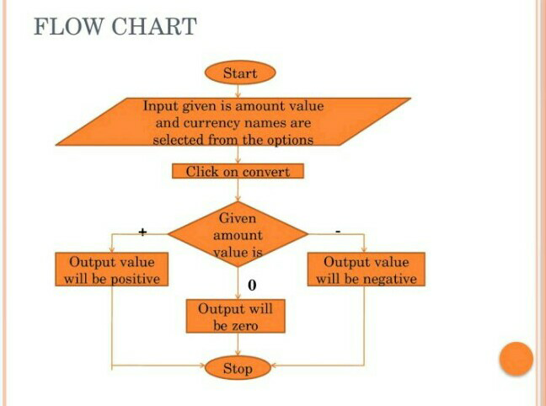



The three layers of architectural design are presentation layer, business layer and access layer.

1) **Presentation layer**:

The front end of the system is in the presentation layer. Interaction of the presentation layer with the user transforms all the activities that the user performs into requests which is then passed to next layer called business layer. When response is received from access layer the results are displayed in a way that is appropriate to the user

2) **Business layer**:

All the calculations and operations in the system are performed by the logic, which is present in this layer. The operations are performed on the data, which is received from the previous layer i.e. Presentation layer. Then the results are stored in the database which is present in the access layer.

3) **Access layer**:

The data is stored to and retrieved from the database

which is present in this layer.

**Algorithm & Process Design**

The user can convert the given currency to currency which he should choose from the **FROM CURRENCY** & **TO CURRENCY** dropdown menu respectively. Then he should give input by putting currency value and select the currency in which he wants to convert the currency. After this all the details get stored in the database i.e., MySQL. Then the converted currency will be displayed.

**Step1:** Start

**Step2:** Enter the amount value

**Step3:** Select the currency from and to

**Step4:** Click on the convert button

**Step5:** The value will be displayed

**Step6:** Exit

**Details of Hardware & Software**

**Windows Operating System**: Windows operating system of 10, 11.

**Python**: Python is a high-level, general-purpose programming language. Its design philosophy emphasizes code readability with the use of significant indentation. Its language constructs and object-oriented approach aim to help programmers write clear, logical code for small- and large-scale projects.

**Tkinter:** Tkinter is a Python binding to the Tk GUI toolkit. It is the standard Python interface to the Tk GUI toolkit, and is Python's de facto standard GUI. Tkinter is included with standard GNU/Linux, Microsoft Windows and macOS installs of Python. The name Tkinter comes from Tk interface.

**MySQL**: It is a software for storage of data.

**Conclusion**

Currency Converter system makes users life more optimistic in finding different currency values. It gives options to choose from various currencies. Our application lets you choose from 6 most used currencies such as INR, USD, CYN, EUR, DKK and CAD, Also It is very accurate as it takes all the currency rates from a library of python called Forex.

**References**

* <https://www.youtube.com/playlist?list=PLu0W_9lII9ajLcqRcj4PoEihkukF_OTzA>
* [https://www.geeksforgeeks.org](https://www.geeksforgeeks.org/python-real-time-currency-convertor-using-tkinter/)